Exploratory Data Analysis (EDA)
- Summary statistics: Use df.describe() to get count, mean, std, min, 25/50/75% percentiles, and max. To compute specific metrics, use df.mean() or df.median() (skips NaNs by default).
- Distribution plots: Draw histograms with df.plot.hist(bins=10, alpha=0.5) to see data distribution. For smooth density estimates, use KDE: df.plot.kde (). For example:
- df['col'].plot.hist(bins=20)
df['col'].plot.kde()
- Outlier detection: Compute z-scores to flag extreme values: e.g.
- from scipy.stats import zscore
df['z'] = zscore(df['col'])
outliers = df[df['z'].abs() > 3]
- Values with |z|>3 are typically outliers. Alternatively, use box plots: df.plot.box(). A boxplot shows Q1–Q3 and whiskers at 1.5×IQR; points beyond whiskers are outliers.

Handling Missing Data
- Detect nulls: Use df.isna() or df.isnull() to create a boolean mask of missing values. To count nulls per column: df.isna().sum(). (df.info() also reports non-null counts.)
- Imputation:
- Fill constants or aggregates: df.fillna(value) or with a dict, e.g. df.fillna({'Age': df['Age'].median(), 'Salary': 0}).
- Forward/backward fill: Use previous/next values with df.fillna(method='ffill') (forward fill) or df.fillna(method='bfill'). For example:
- df_ffill = df.fillna(method='ffill')
- This replaces each NaN with the last non-null above it.
- Interpolation: For evenly spaced or time-indexed data, use df.interpolate(). Linear interpolation fills gaps by connecting known points. For time-series data (datetime index), use df.interpolate(method='time'), which estimates missing values based on time intervals.

The apply() Function
- Axis parameter: df.apply(func, axis=0) (default) applies func to each column; use axis=1 to apply per row. Each call receives a Series (row or column) and should return a scalar or list.
- Examples:
- Column-wise (e.g., apply a NumPy function):
- df.apply(np.sqrt) # applies sqrt to all entries
- Row-wise (e.g., sum of row values):
- df['sum'] = df.apply(lambda r: r['A'] + r['B'], axis=1)
- Here, each row r is a Series, and the lambda returns a scalar.

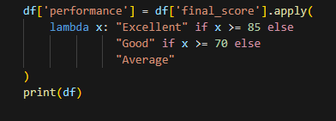
1) Exploratory Data Analysis (EDA)
Summary Statistics:
df.describe()
df['A'].mean()
df['A'].median()
Z-Score Outlier Detection:
mean = df['A'].mean()
std = df['A'].std()
df['z'] = (df['A'] - mean) / std
df[df['z'].abs() > 3] # |z| > 3
IQR Method:
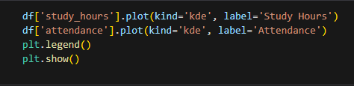
Q1 = df['A'].quantile(0.25)
Q3 = df['A'].quantile(0.75)
IQR = Q3 - Q1
lower = Q1 - 1.5 * IQR
upper = Q3 + 1.5 * IQR
Visualization:
df['A'].plot(kind='hist') # Histogram
df['A'].plot(kind='kde') # KDE
2) Handling Missing Data
Detect Missing Values:
df.isna().sum()
Fill Missing Values:
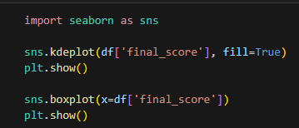
df.fillna(0)
df['A'] = df['A'].fillna(df['A'].mean())
Forward / Backward Fill:
df.fillna(method='ffill')
df.fillna(method='bfill')
Interpolation:
df.interpolate()
df.interpolate(method='time') # time-series
3) The apply() Function
Column-wise (default axis=0):
df.apply(np.mean)
Row-wise (axis=1):
df.apply(np.sum, axis=1)
Create New Column:
df['total'] = df.apply(lambda row: row['A'] + row['B'], axis=1)
Conditional Labeling:
df['group'] = df['age'].apply(lambda x: 'Adult' if x>=18 else 'Minor')
Vectorization Preferred:
df['A'] * 2 # Faster than apply()

